1. To review pay group, cost center and other important data for a new hire or employee who had a job change you will search for the employee by typing the employee name



1. Click on the employee’s name

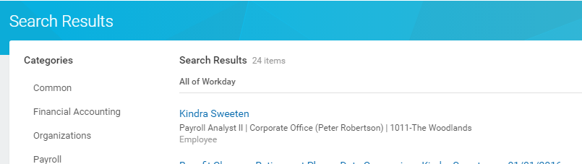

1. While on the Job tab you will want to click on Organizations

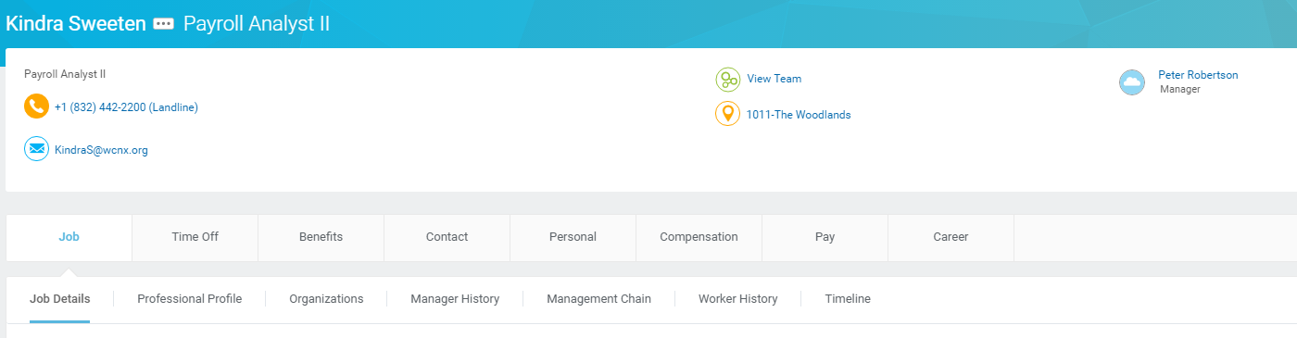

1. Here you will find the Cost center, Location, Pay Group and Department

